EVS project: YES! to sustainability
(the project is already approved by EU, the sending organisation is CEDRA Split)

Zavod Veles (SUSTAINABLE FAMILY FARM – SLOVENIA, region Posavje/Dolenjska)
Site: http://www.kmetija-veles.si/
Facebook: Kmetija Veles
Video: https://www.youtube.com/watch?v=U8YiTY5yMaI&t=58s
https://www.youtube.com/watch?v=JMH0vFbgzL0
https://www.youtube.com/watch?v=MXaSWlj-wQE&t=72s

PRINCIPAL ACTIVITIES - Ecobuilding, Permaculture, Social permaculture, Workshops, Network of community initiatives in Slovenia
Contact person:
Petra Jazbec, petrajazbec33@gmail.com - hosting organisation, Zavod Veles, Zavod za trajnostni način življenja, so.p.;
Michael Freer, michaelfreer@gmail.com - sending organisation, Cluster za eko-društveni razvoj i inovacije - CEDRA Split.

DURATION OF EVS: start: if possible with 1.6.2017 – 30.11. 2017
THE WIDER OBJECTIVE:
Open the possibility to young people to experiment the living in rural communities, ecovillages and family farm.
The volunteer will be involved in ecobuilding, permaculture, social permaculture, children and youth education, activities of local integration in the region (loc. community and family farm). Besides that he/she will learn about community gardening, divulgation of activity of the hosting org, fund raising research, interaction with media, getting to know and visit other community based iniciatives in Slovenia and different ways of creative expression (art, music, circus).

EXPLANATION OF ACTIVITIES FOR THE EVS VOLENTEER:
The farm has variety of activities that are connected with sustainable living and community – so the program of the EVS volunteer will foster the development of his/her needs and interests in the fields he/she wants. It is also connected to a broader network of social and ecological initiatives in Slovenia – in which the volunteer can also be active by his wish. The organization will be supportive to the volunteers personal project. The organization can support the EVS volunteer strongly in the fields of eco-building, permaculture, social permaculture, youth work and other fields (see the description of the organization). Besides that the volunteer will help with different events (natural building workshops, youth exchange, permacultural workshops, children camp, picking wild plants, ect.). In the EVS program also short learning visits to other sustainable places-farms-communities-organizations in Slovenia are planned (to get to know different sustainable projects).

PRACTICAL INFORMATION ABOUT THE PLACE:
It is located in the village Svinjsko. Isolated 8 km to the shop, or transport.
But they take children to school, so can accompany the volunteer or offer them to take a bike.
5 people living on the farm, family (4 people) + 1 volunteer from 4 years integrated.
There are Heplx, Wwoofing, Workaway and other volunteers. So sometimes there are 20 people, sometimes just 5.
Accomodation for volunters: possible in teepee tent or opened space dormitory in summer time, in winter time a room with heating.

MOTIVATION for sustainable way of life is a key.

ABOUT THE ORGANIZATION:

Zavod Veles is the family non-profit organisation which includes volunteers from local and abroad. The main aim of Zavod Veles is to support and promote sustainable way of living. To show, teach and to allow people to try to live it this way. We are experts in natural building for teaching and making it. Other topics, such as permaculture farming, preserving of the food, natural cosmetic, social permaculture, youth work and education, social economy, local connection and integration, take a big part of our focus: in the way to educate ourselves and on the other hand to pass it on to volunteers, participants of workshops with didactic skills.
We try to integrate the permaculture principles in every activity that is part of our organisation.
The seat of organisation is on the farm so we spontaneously include in our day-life producing and processing the food for sustainability of the organisation.
On the farm and sometimes on the other places we organise workshops about:
- including sustainable way of living in every day life;
- natural building;
- permaculture farming;
- social permaculture;
- youth work;
- producing, processing and preparing the food;
- picking wild plants and medicinal plants and how to prepare it;
- natural cosmetic and herbs

Because we are specialised in natural building we also prepare our clay for building for others and we teach others how they can do it on their own (self-builder). Our goal is that people learn how to be self-supply as possible and that they have an idea and motivation how they can change their lives when they return home if they want to do this. We are building a Sustainable Educational Centre where we will be able to link above mentioned activities. The people we are welcoming are people interested in sustainable lifestyle, simple life in nature without overwhelming luxury, in natural building and ecological farming.
Organisation' s activities are supported by two members of family which have professional knowledge about natural building, permaculture and education. Volunteers joining our farm, our organisation take part in our projects and will have the support to develop also their own interest into their projects.
Zavod Veles is a new organisation, established in January 2016. As a beginner we put our energy in networking, connecting, being known, coworking. Organisation became part of many sustainable networks and started to collaborate with other organisation and initiatives that support sustainability. Like that Zavod Veles became s social enterprise.

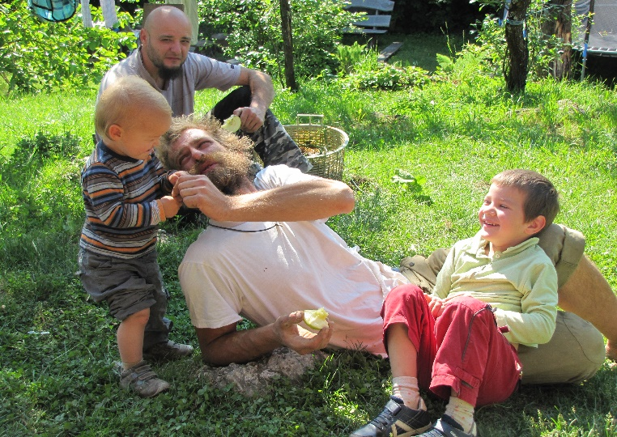 | 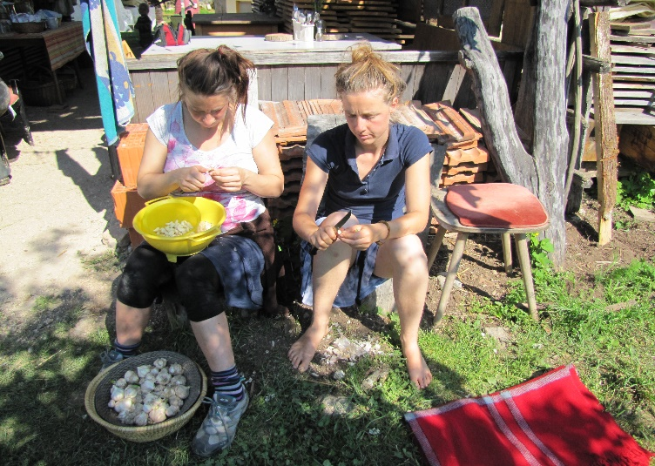 | 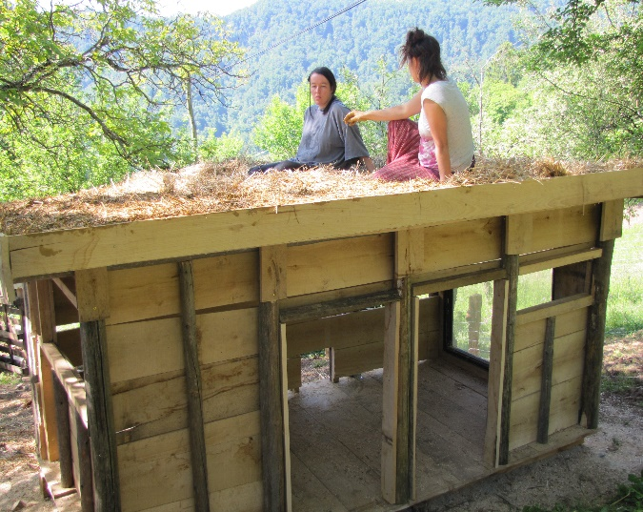
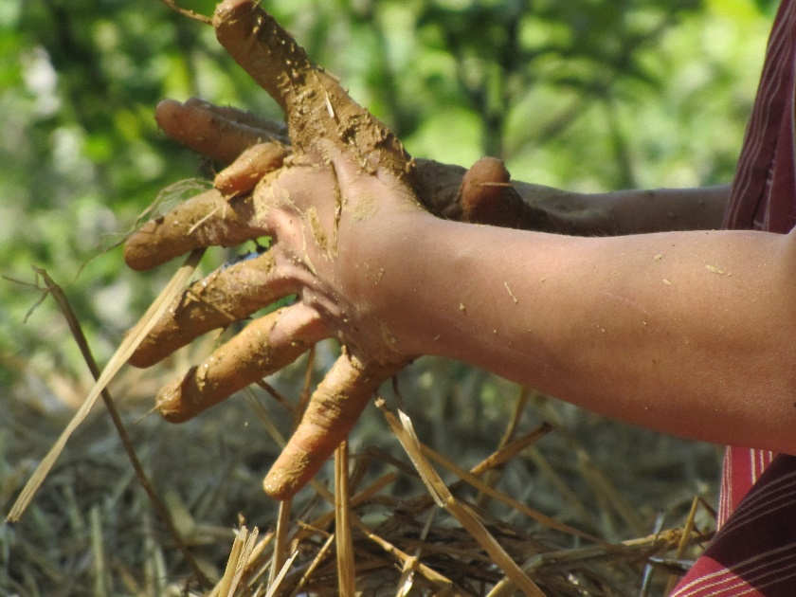 | 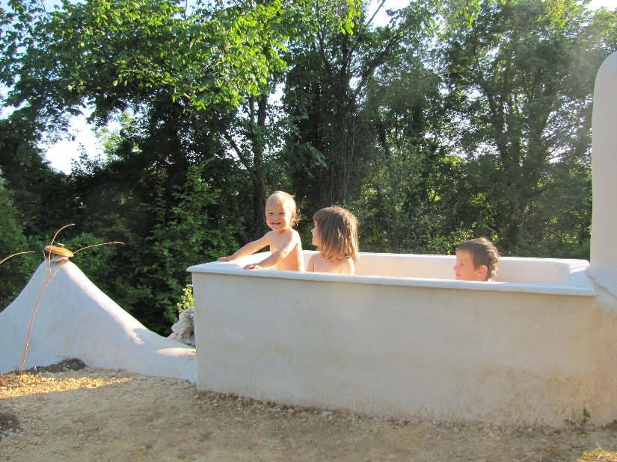 | 